**MIS 6308: System Analysis and Project Management**

**Assignment 1**

1. Following attributes are being maintained for Restaurant class:
   1. Name
   2. Logo
   3. Address
   4. Contact number
   5. Delivery hours
   6. Ratings
   7. Number of reviews
   8. Average delivery time
   9. Delivery area (zip codes or range of area for service)
   10. Average cost (ranging from pocket-friendly to very costly)
   11. Types of cuisines served
   12. Special offers (if any applicable for the whole restaurant)
2. Classification of restaurant type can be done based on following parameters:
   1. Different types of restaurants can be classified as following using Generalization:

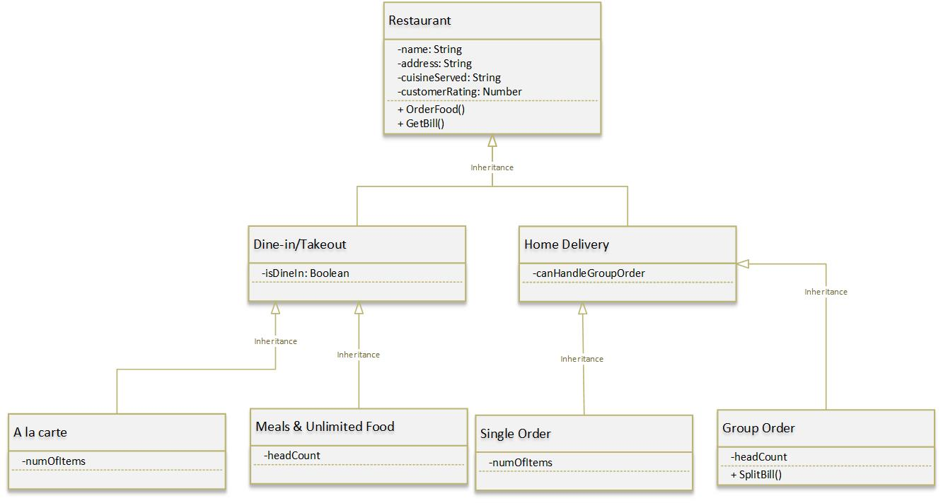

* 1. Menu can be modeled as shown by following diagram using Aggregation:

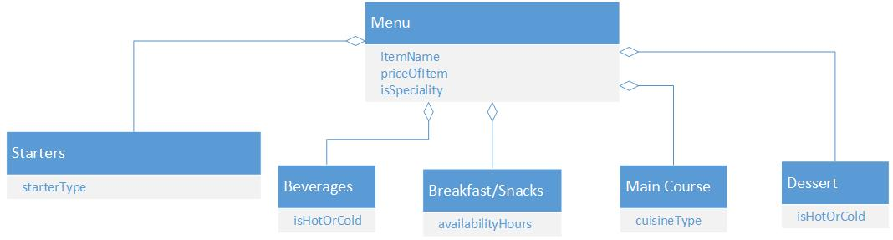

1. Solution for each question is as below:
   1. Attributes inherited by
      1. Order – None
      2. Group Order – Order#, OrderDate and OrderTotal
      3. Single Order – Order#, OrderDate and OrderTotal
   2. Methods inherited by
      1. Order – None
      2. Group Order – PayDriver
      3. Single Order – PayDriver
   3. “Deliver Order” method is an example of Polymorphism.
   4. For object of Group Order, the interface is PayDriver, Send Link to Group and Deliver Order.

1. The models are as follows:
   1. Process diagram for placing an order is as follows:

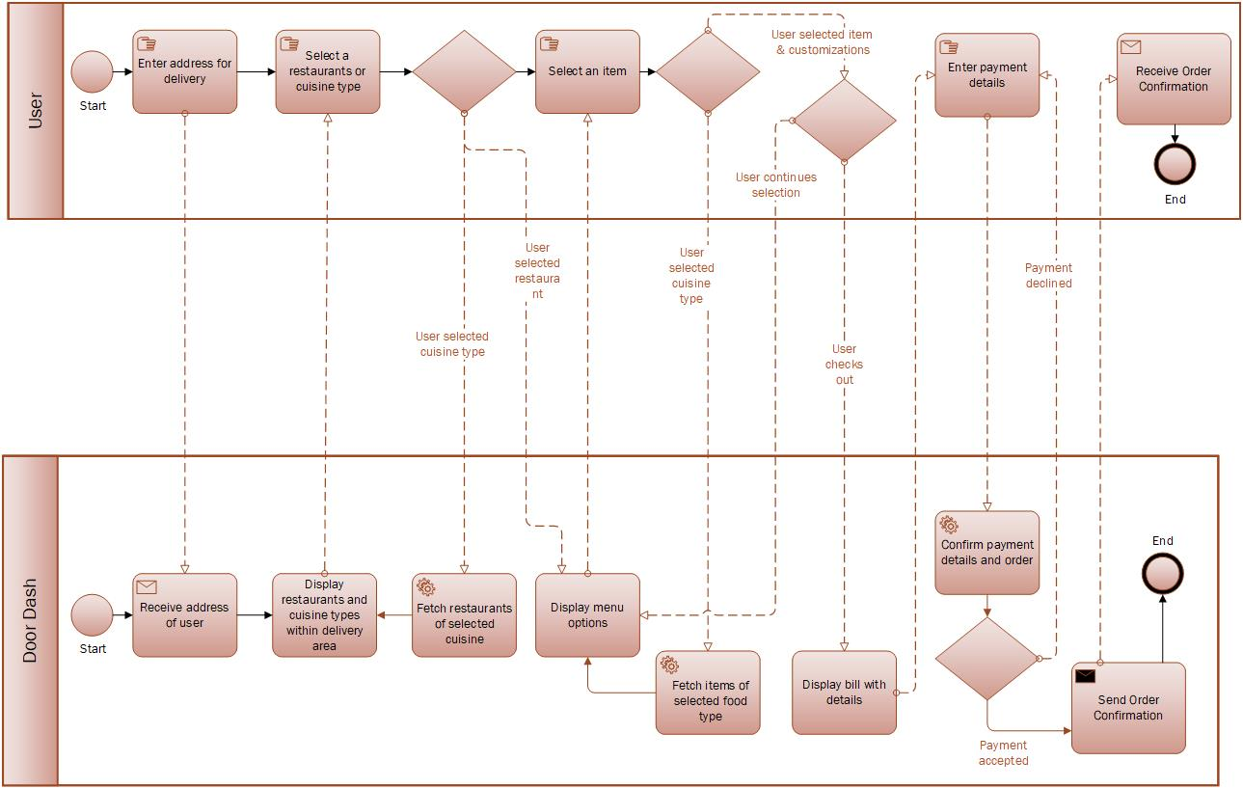

* 1. Choreography diagram for placing an order is as follows:

